LAB EXPERIMENT

SET 30: MOBILE APP USAGE ANALYSIS

Department | AIDS
Course Code / Course Name | DSA0602 / Data Handling and Visualization
Experiment | Data Visualization using R and Tableau
Name | D.HEMASREE
Register Number | 192524114
Date | 22 October 2026
Day | Thursday

Aim
To analyze mobile app usage data using a histogram with a density plot, a scatter plot with a trend line and a bar chart in R, and to build a bubble chart, a line chart and a mini dashboard in Tableau.
Dataset: Mobile_App_Usage.csv

User_ID | Gender | Age | Screen_Time (hrs) | App_Usage_Count | Data_Used (GB) | Satisfaction | Usage_Date
U01 | Male | 20 | 4.5 | 18 | 2.4 | 3 | 2025-01-08
U02 | Female | 22 | 6.0 | 25 | 3.8 | 5 | 2025-01-08
U03 | Male | 19 | 3.2 | 12 | 1.6 | 3 | 2025-02-11
U04 | Female | 21 | 7.1 | 30 | 4.5 | 5 | 2025-02-11
U05 | Male | 23 | 2.8 | 10 | 1.2 | 2 | 2025-03-14
U06 | Female | 20 | 5.4 | 22 | 3.1 | 4 | 2025-03-14

PROGRAM 1: Histogram and Density Plot of Screen Time
Import the dataset in R. Plot a histogram and density plot for Screen_Time. Add suitable colors and labels. Interpret the screen-time distribution.
library(ggplot2)

usage <- read.csv("Mobile_App_Usage.csv") print(usage)

ggplot(usage, aes(x = Screen_Time)) +
geom_histogram(aes(y = after_stat(density)), binwidth = 1, boundary = 2, closed = "left", fill = "steelblue", color = "white") +
geom_density(color = "darkorange", linewidth = 1.2) + labs(title = "Distribution of Screen Time",
x = "Screen Time (hrs)", y = "Density")

OUTPUT:

U  1 | ser_ID  U01 | Gender Male | Age Scre 20 | en_Time App_Us 4.5 | age_Count Da  18 | ta_Used Satis 2.4 | faction Usage_Date  3 2025-01-08
2 | U02 | Female | 22 | 6.0 | 25 | 3.8 | 5 2025-01-08
3 | U03 | Male | 19 | 3.2 | 12 | 1.6 | 3 2025-02-11
4 | U04 | Female | 21 | 7.1 | 30 | 4.5 | 5 2025-02-11

5 | U05 | Male | 23 | 2.8 | 10 | 1.2 | 2 2025-03-14
6 | U06 | Female | 20 | 5.4 | 22 | 3.1 | 4 2025-03-14
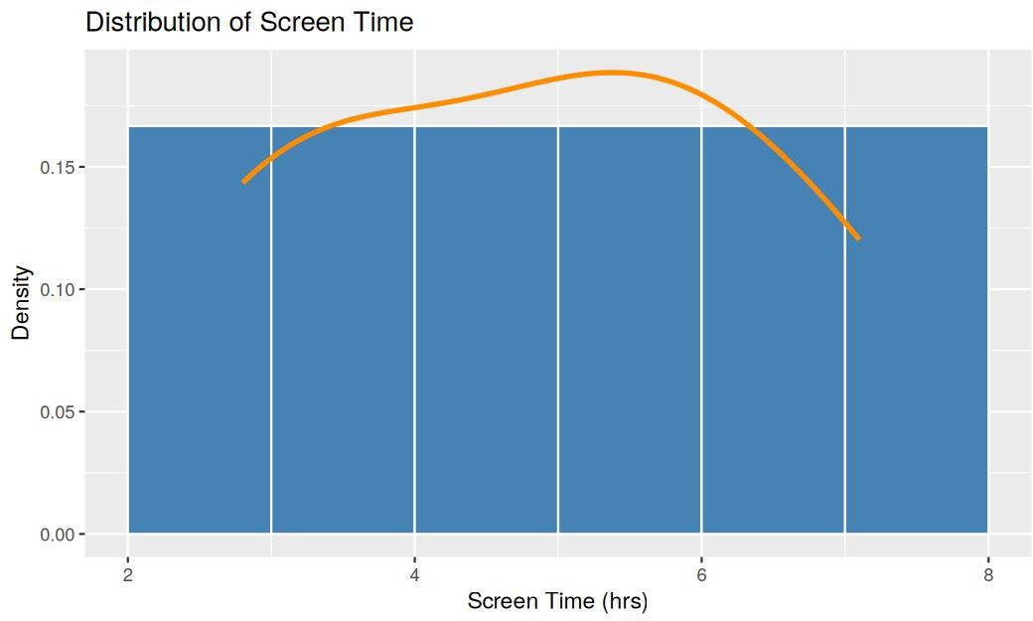
Output 1: Distribution of Screen Time (Histogram and Density Plot)

Observation:
Screen_Time ranges from 2.8 to 7.1 hours, with a mean of 4.83, a median of 4.95 and a standard deviation of about 1.66. Each one-hour bin from 2 to 8 holds exactly one user, so the usage is spread evenly with no single dominant group. The density curve is smooth and highest at about 5.4 hours, and it falls gently towards both ends. Since the mean and median are close, the distribution is roughly symmetric, and there are no outliers. With only six users, the shape is only indicative.

PROGRAM 2: Scatter Plot of Data Used and Screen Time
Create a scatter plot using R programming between Data_Used and Screen_Time. Calculate the correlation between them. Add a trend line. Explain the relationship.
library(ggplot2)
usage <- read.csv("Mobile_App_Usage.csv") ggplot(usage, aes(x = Data_Used, y = Screen_Time)) +
geom_point(color = "steelblue", size = 4) +
geom_smooth(method = "lm", se = FALSE, color = "darkorange") + labs(title = "Data Used vs Screen Time",
x = "Data Used (GB)",
y = "Screen Time (hrs)")

cor(usage$Data_Used, usage$Screen_Time)

OUTPUT:
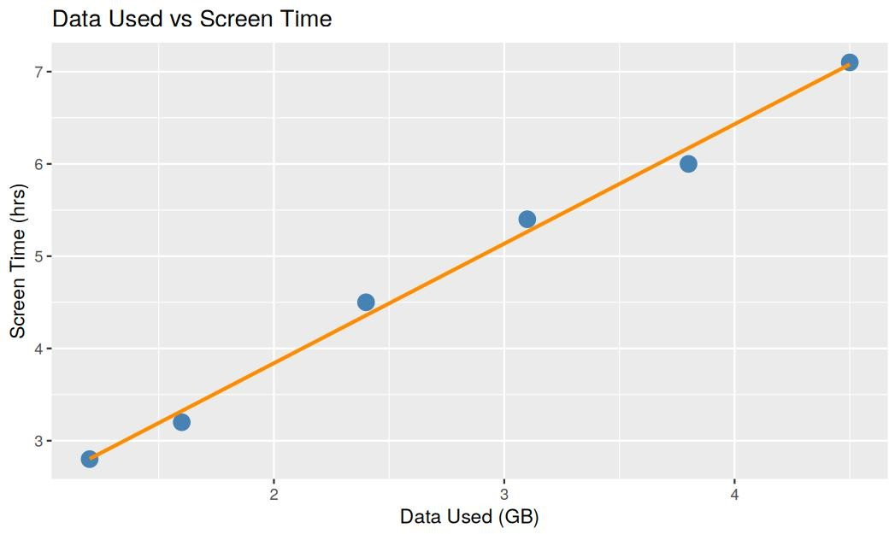
Output 2: Data Used vs Screen Time (Scatter Plot with Trend Line)
[1] 0.9969674

Observation:
The correlation between Data_Used and Screen_Time is 0.997, which is a very strong positive relationship. The points lie very close to the trend line, which is about Screen_Time = 1.25 + 1.30 × Data_Used, so each extra GB of data goes with about 1.3 more hours of screen time. Users who spend more time on the screen use more data. This shows that the two move together but does not prove that one causes the other, and the result is based on only six users.

PROGRAM 3: Bar Chart of Average Satisfaction by Gender
Using R, find the average Satisfaction score for each Gender. Create a bar chart for the averages. Add value labels. Interpret user satisfaction patterns.
library(ggplot2)

usage <- read.csv("Mobile_App_Usage.csv")

avg_sat <- aggregate(Satisfaction ~ Gender, data = usage, FUN = mean) print(avg_sat)

ggplot(avg_sat, aes(x = Gender, y = Satisfaction, fill = Gender)) + geom_col(width = 0.6) +
geom_text(aes(label = round(Satisfaction, 2)), vjust = -0.5) + scale_fill_manual(values = c("Female" = "darkorange", "Male" = "steelblue")) + ylim(0, 5) +
labs(title = "Average Satisfaction by Gender", x = "Gender",
y = "Average Satisfaction")

OUTPUT:
Gender Satisfaction
1 Female 4.666667

2 Male 2.666667
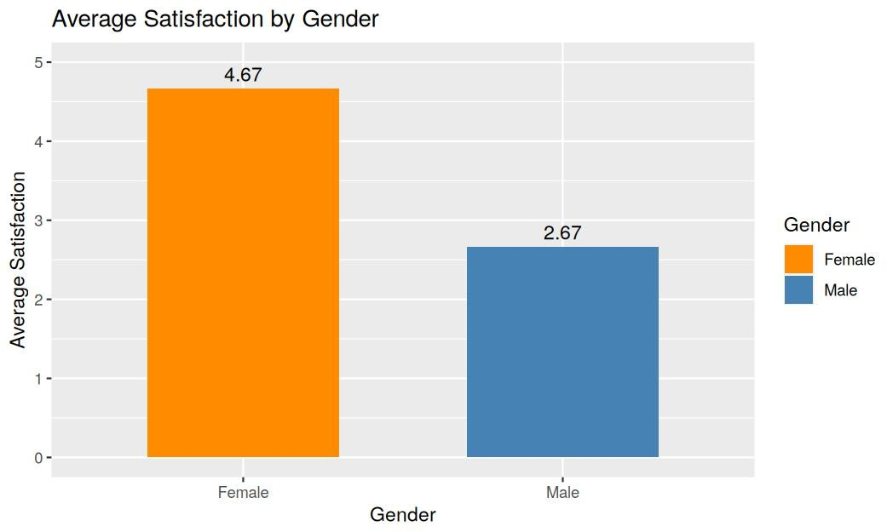
Output 3: Average Satisfaction by Gender (Bar Chart)

Observation:
Female users have an average satisfaction of 4.67 and male users have an average of 2.67, so female users are two points more satisfied. Female users also have higher screen time (6.17 hours against 3.50 hours) and higher data use (3.80 GB against 1.73 GB). This suggests that the users who use the app more are the more satisfied ones, while the male users with lighter usage rate it lower.

PROGRAM 4: Bubble Chart, Line Chart and Mini Dashboard in Tableau
Import Mobile_App_Usage.csv into Tableau. Create a bubble chart (Screen Time vs Data Used). Use color for Gender and size for App Usage Count. Create a line chart for usage trends. Add filters for Gender and Usage_Date. Design a mini dashboard.

Steps in Tableau
- Connect to the file (Connect > Text file) and select Mobile_App_Usage.csv. Check that Usage_Date is read as a Date field.
- Sheet 1 (Bubble Chart): Drag Screen_Time to Columns and Data_Used to Rows. Drag User_ID to Detail so that each user is a separate point. Change the Marks type to Circle, drag Gender to Color and App_Usage_Count to Size. Rename the sheet "Usage Bubble Chart".
- Sheet 2 (Line Chart): Drag Usage_Date to Columns (right-click and choose Exact Date) and Screen_Time to Rows (SUM). Drag Gender to Color so that there is one line per gender. Turn on mark labels and rename the sheet "Usage Trend".
- Drag Gender and Usage_Date to Filters, right-click each filter and choose Show Filter. Choose Apply to Worksheets > All Using This Data Source so that both sheets respond.
- Create a new Dashboard (Dashboard > New Dashboard), set the size to Automatic and drag the two sheets onto the dashboard area. Place the Gender filter, Usage_Date filter and the color and size legends beside the charts.
- Select each chart and click Use as Filter, add the title "Mobile App Usage Dashboard", and test the filters in Presentation Mode.

OUTPUT:
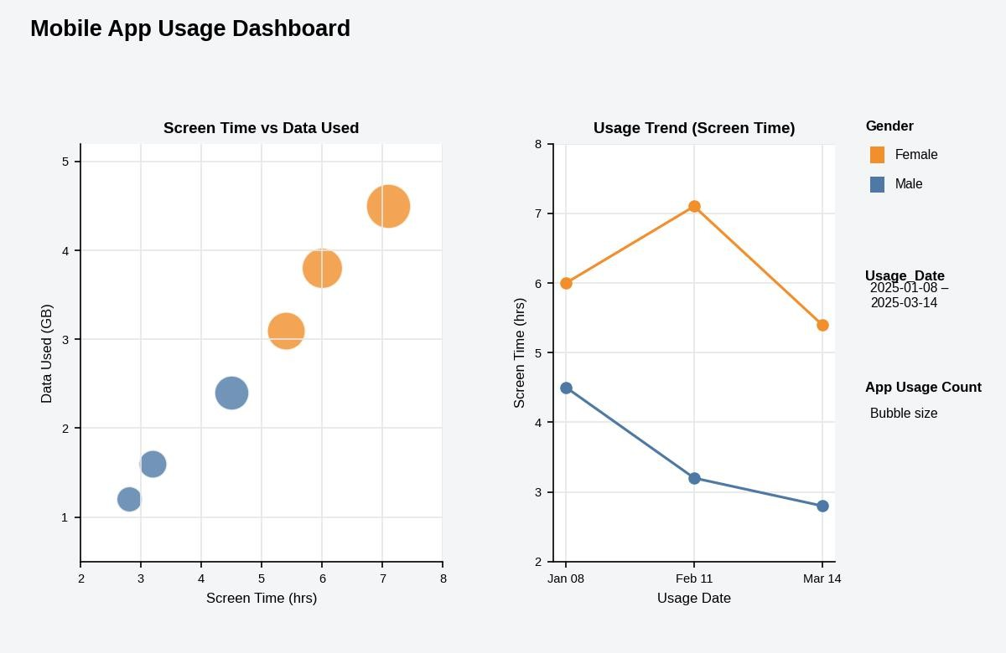
Output 4: Mobile App Usage Dashboard (Tableau)

Observation:
In the bubble chart, the female users (orange) have higher screen time, more data use and larger bubbles (22 to 30 app uses) than the male users (blue, 10 to 18 app uses). In the line chart, the screen time of male users falls from 4.5 hours in January to 3.2 in February and 2.8 in March. The screen time of female users rises from 6.0 to 7.1 hours and then falls to 5.4. The Gender and Usage_Date filters update both charts together.

Procedure
- Save the data as Mobile_App_Usage.csv and import it into R using read.csv().
- Use ggplot2 with geom_histogram() and geom_density() to plot the distribution of Screen_Time.
- Use geom_point() and geom_smooth(method = “lm”) to draw the scatter plot with a trend line, and calculate the correlation using cor().
- Find the average Satisfaction for each Gender using aggregate() and draw the bar chart with geom_col() and geom_text().
- Load the file into Tableau and build the bubble chart and the line chart worksheets.
- Combine the worksheets in a Tableau dashboard and add the Gender and Usage_Date filters.

RESULT:
The mobile app usage data was successfully analyzed in R using a histogram with a density plot, a scatter plot with a trend line (correlation 0.997) and a bar chart of average satisfaction by gender. A Tableau dashboard with a bubble chart, a line chart and filters for Gender and Usage_Date was also created.

Key Functions and Tools Used

Function / Tool | Purpose
read.csv() | Imports the dataset into R.
geom_histogram() / geom_density() | Creates the histogram and density plot.
geom_point() / geom_smooth() | Creates the scatter plot with a trend line.
cor() | Calculates the correlation.
aggregate() | Finds the average satisfaction for each gender.
geom_col() / geom_text() | Creates the bar chart with value labels.
Tableau Bubble Chart | Shows Screen_Time against Data_Used with color and size.
Tableau Line Chart / Filters | Shows usage trends and filters by Gender and Usage_Date.

